Theme Connections 2018-19 Art Activism = Dance Activism Read the Headlines below!
2018 Teenager #MaedehHojabri was arrested for posting videos of herself dancing on Instagram. Modesty laws in Iran forbid women from dancing in public. One of the four women arrested for her videos, teenage Insta-star Maedeh Hojabri, made what many believed to be a forced confession on Iranian state TV, according to the BBC.But the authorities' attempt at public shaming backfired: Since the confession aired, Hojabri has become the face of a new resistance movement.Using hashtags like مائده_هژیری, which roughly translates to #dancing_isn't_a_crime, people throughout the country and across the world have been posting videos of themselves dancing to show just what they think of these modesty laws.
Question to reflect upon: How does social media influence protests today?
Climate and Environmental Awareness
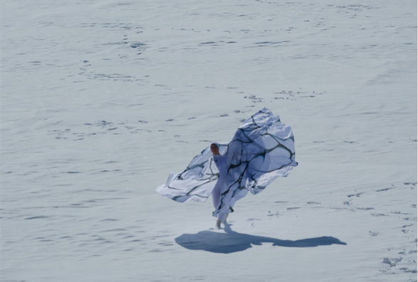
Jody Sperling's Bringing the Arctic Home, which premiered in 2015, was inspired by her experience accompanying a scientific mission and dancing on Arctic ice. "I felt charged by this very remote place," she says. "It gave me a strong sense of immediacy." Now, she's working on a project about changing wind patterns. Source: Dance Magazine
Question to ponder: Would you enjoy experiencing dance outside, in a more natural environment (site specific work)?
Able and Differently Abled: Increasing Social Awareness
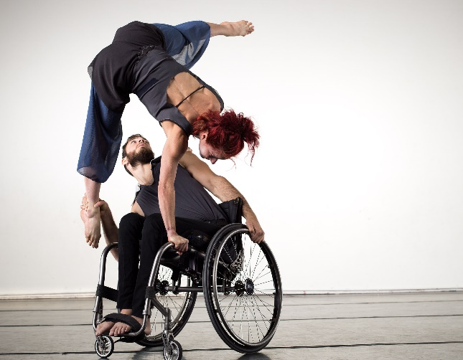 Axis Dance Company: Changing the face of dance and disability
Did you know that there are dance companies for the elderly to participate in to? What artists do you know that challenge the norm of who can participate?
Check out these videos:
https://www.youtube.com/watch?v=P0ic5gNsNSM
Revolutionary danced by Lori Belilove in this video
Created and Originally danced by modern dance originator Isadora Duncan (1921, no video exists of her dancing)
Isadora left the United States to live in both Russia and France, she created this dance as an expression of the suffering experienced during the imprisonment of serfs during the uprising known as the Russian Revolution.

https://www.youtube.com/watch?v=FaZQsZUsytc
The Green Table, danced by Joffrey Ballet
Created by Kurt Joos, a German choreographer in the 1930s
This dance pokes fun at politicians in their attempt to negotiate a peace agreement. This satire is a reaction to the “destructive impulses” that lead to war. Keep in mind that he was living in Germany at the time of Hitler’s military climb to power. The excerpt you are viewing is lighthearted yet the full ballet explores power struggles, manipulation, and death.

https://www.youtube.com/watch?v=kLHUOV7f78k
“Yo Taxi” is an excerpt from Savion Glovers Broadway Show Bring in Da Noise, Bring in Da Funk (1995,96)
This dance highlights discrimination faced by African American men trying to get a cab in NYC. No matter what they are wearing –street clothes, business suit, military uniform, they are unable to get a taxi cab to stop for them. The entire Broadway show explored the challenges African Americans have faced in the US.

After reading and viewing the videos answer the following in an email to Jackie.Sacks@ vansd.org
- Which example of dance activism do you think will stick with you the most and why?
- What social topic do you think would be interesting to see explored through dance?

