Ballet vocabulary used in class 8 positions of the body
Demi plie´
Grand plie´
Releve´
Eleve´
Tendue
De´gage´
Rond de jambe
Echappe´
Developpe’
Promenade
Passe´
Battement
Balance´
Pique
Chaine´
Port de bras
En dehors and En dedans
Arabesque ( 1st, 2nd, 3rd, penche)
Attitude
Jete’
Changement (saute’)
Assemble’
Coupe’
Fondu
glissade
Pas de bourre’e and Pas de chat
Student________________________________________________________________________________
Identify - write the term that matches the movement
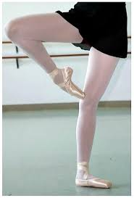 ______________________________________________________________

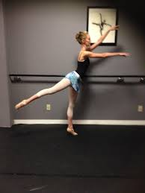 ________________________________________________________________
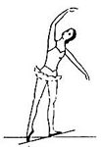 ____________________________________________________________________

This term means carriage of the arms. __________________________________________________

This term describes movement coming into the body or inside. _____________________________________

This term describes the action of half -circling of the leg. ____________________________________________
This term means escape and describes feet moving away then back towards each other. ________________________________________________________

This term means “ to walk” but describes the rotation around one’s body w/ the heel initiating small movements to force the turn. _______________________________________________________________

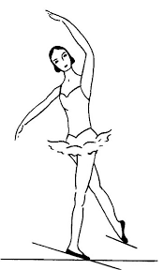 _______________________________________________________________

Identify what Mrs. Sacks demonstrates

_____________________________________________________

_________________________________________________________

_______________________________________________________

_______________________________________________________

_______________________________________________________

