Flash Boat

Open Adobe Flash CS3 Professional. Click Flash File (ActionScript 3.0) under “Create New”
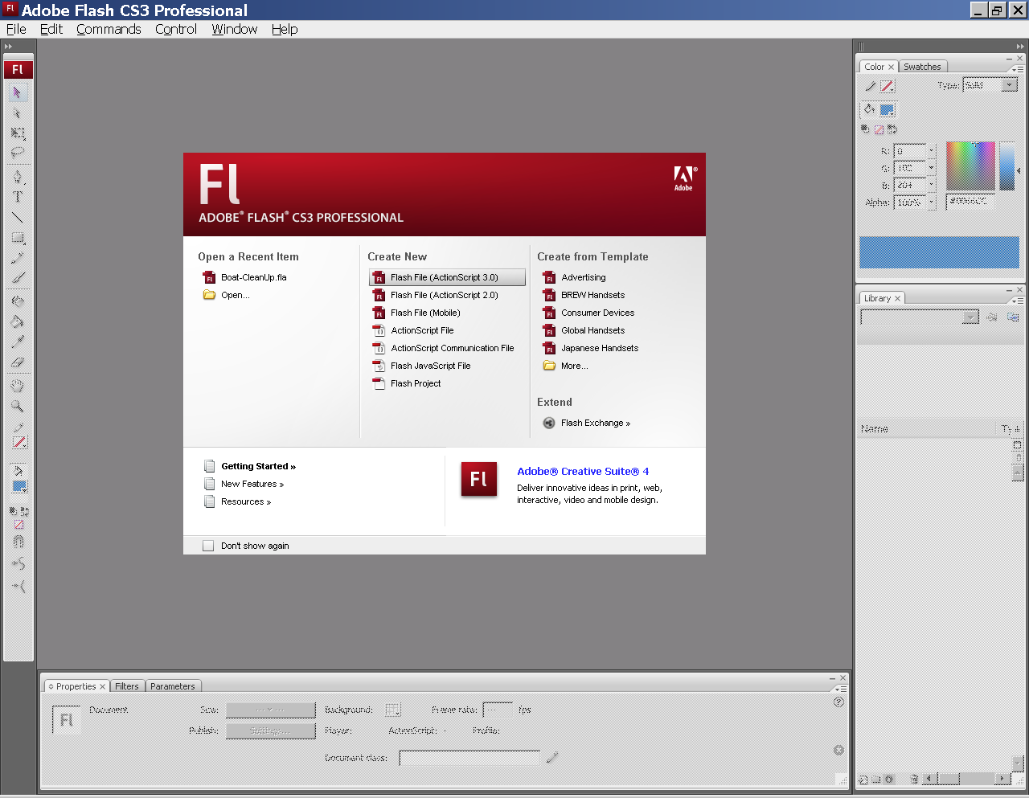

Background Layer
Create a radial gradient with yellow in the middle and blue on the outside. The yellow tab should be drug to the right 1/8 of an inch. The blue tab should be drug so it’s 1/8-1/4 inch to the right of the yellow tab. Look at the sample below, inside the red circle.
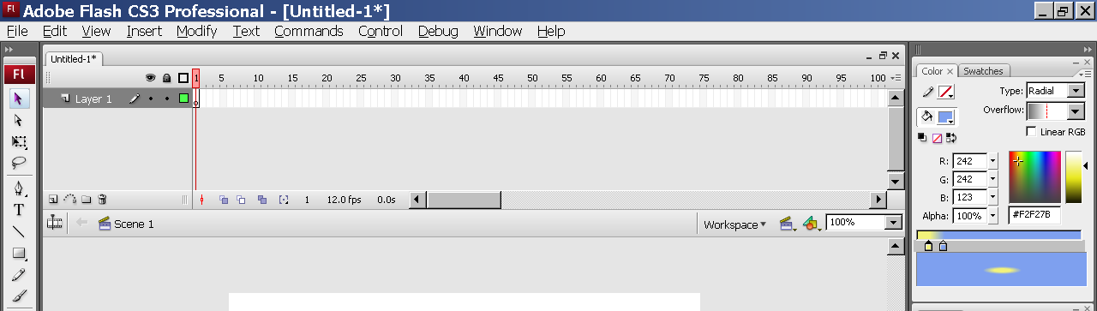

Draw a rectangle so it covers the entire white canvas.
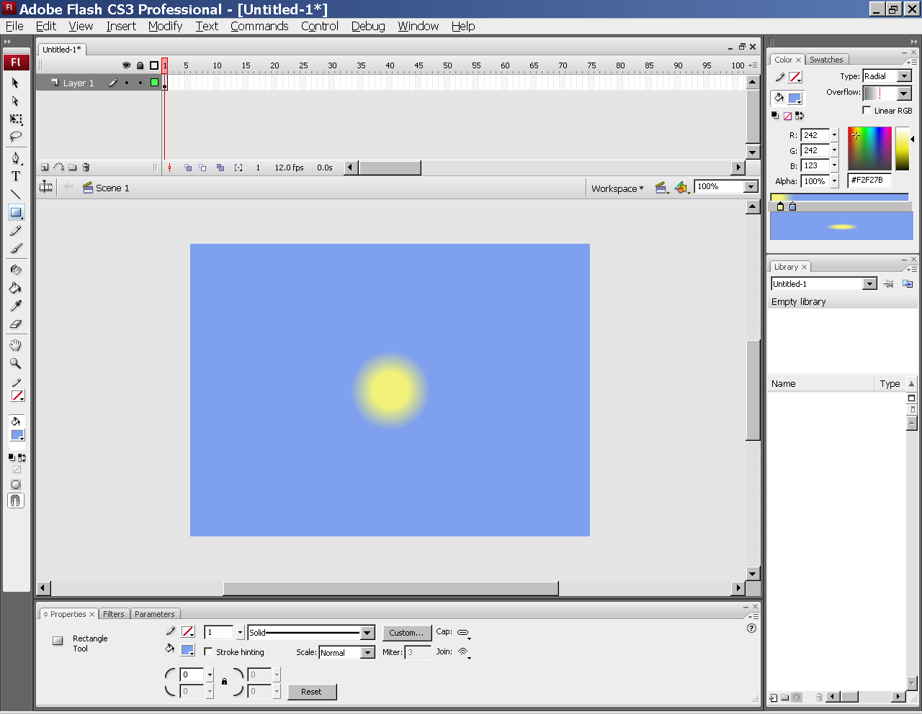

Using the paint bucket tool, click inside the rectangle you just drew where you want the sun to be at the start of the movie.
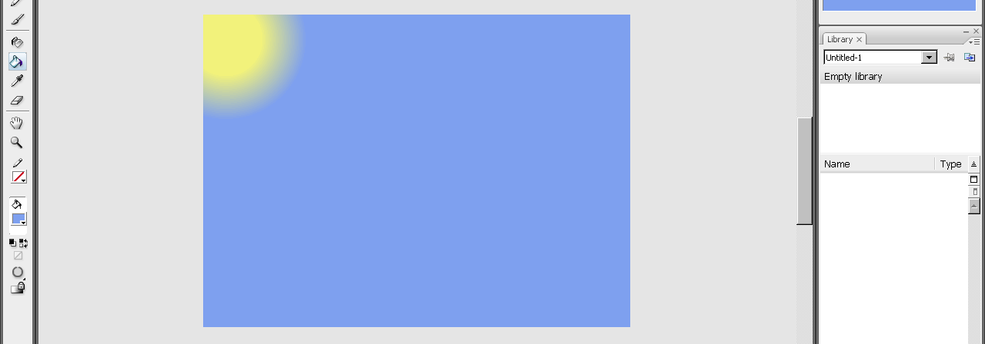

Rename Layer 1 to “Background”. (Double click on Layer 1 to rename it.)
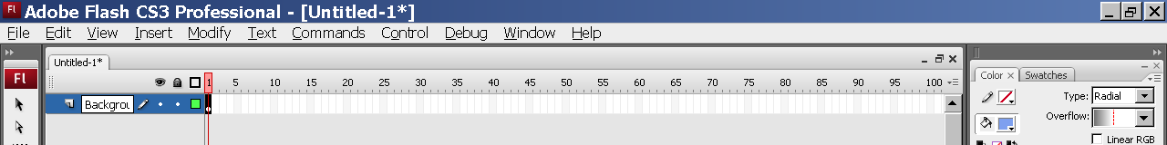

On frame 60 of the Background layer – Insert a Keyframe from the Insert>Timeline menus. (You can also right click on the timeline at the frame/layer you want to insert at.)
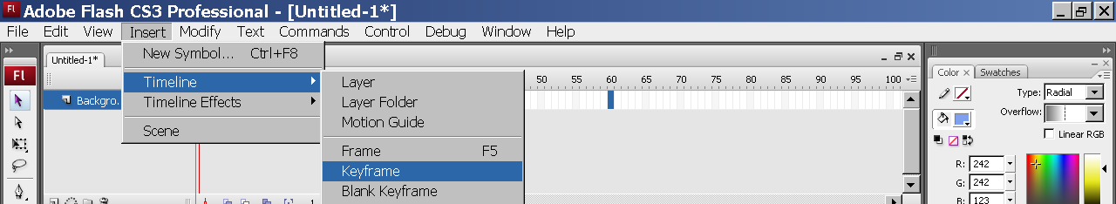 (or)
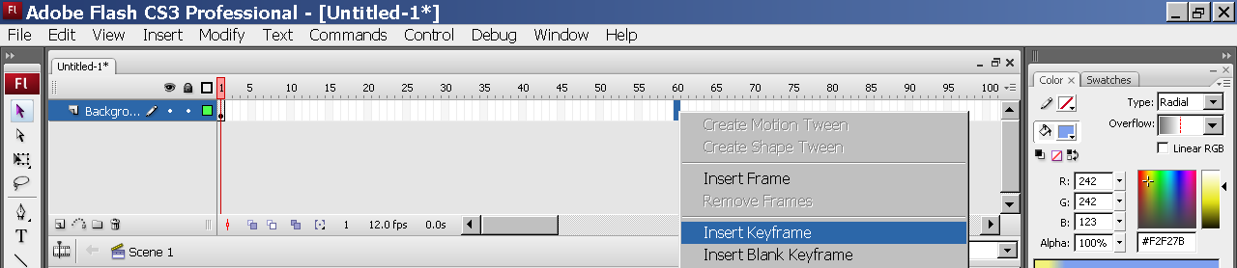

Using the paint bucket again, click where you want the sun to be at the end of your movie.
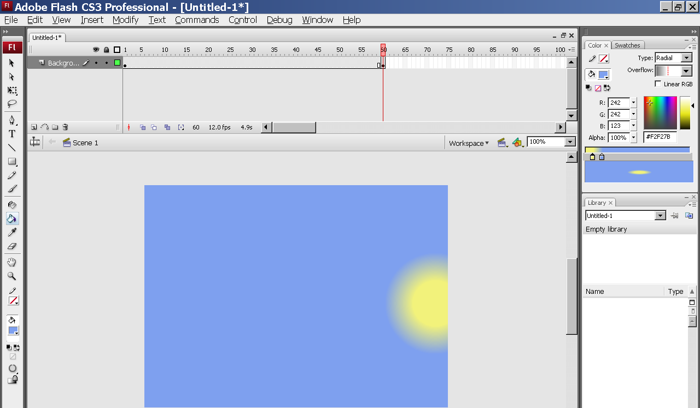

Click on the Background layer name – this selects all frames in the layer – and in the Properties inspector, choose Shape from the Tween pull-down menu.
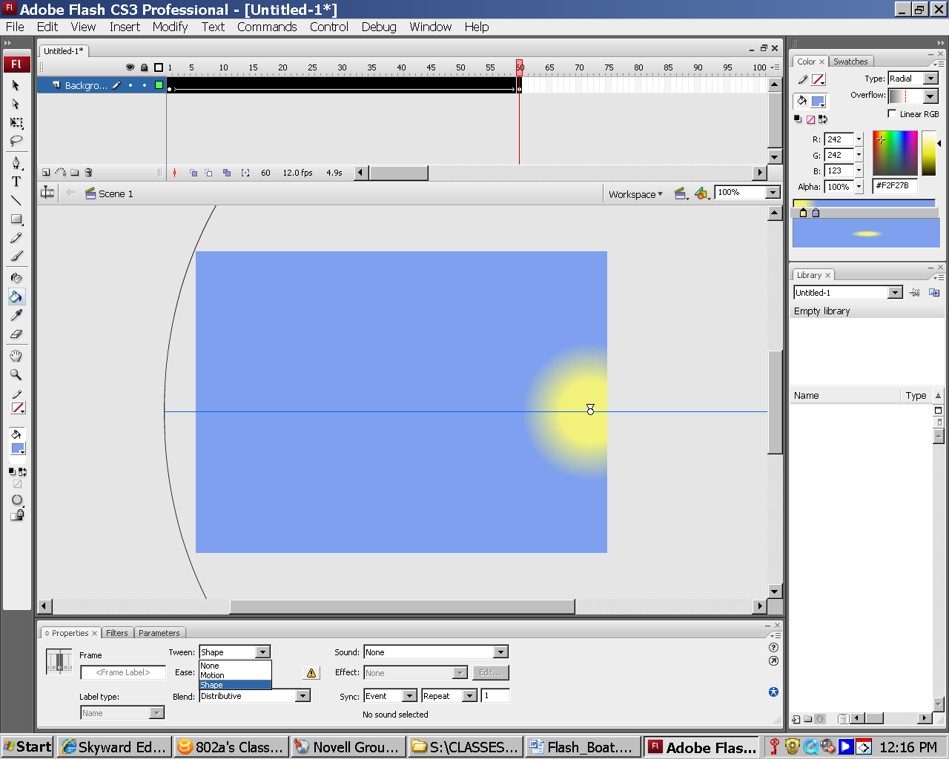

Wave Layer 1
Choose Insert>Timeline>Layer from the menus.
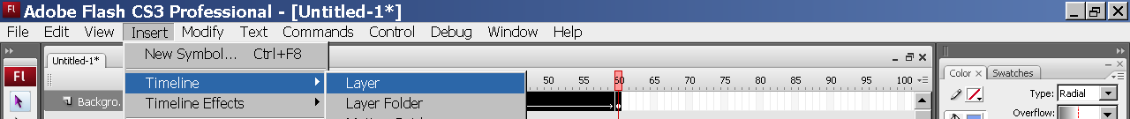

Name this layer Wave 1.
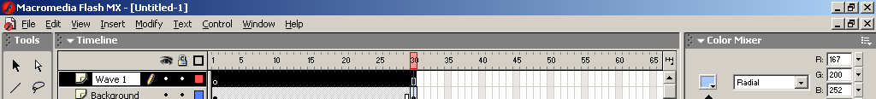

Using the pencil tool with the smooth option, draw a wave shape. When you get to the other side of the canvas, draw down, across the bottom and back up to where you started so you have a complete shape that can be filled.
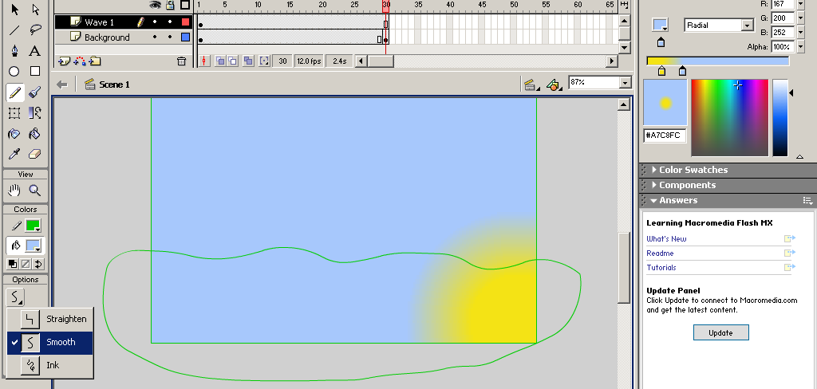

Using the paint bucket, choose a blue that is different then your background and click inside the wave.
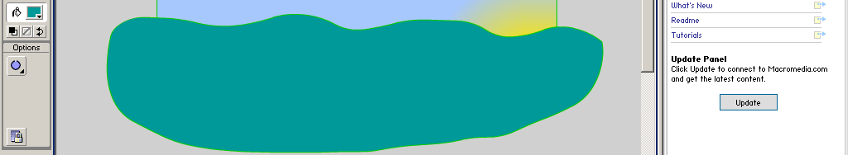
At frame 30 of your Wave 1 layer, choose Insert>Timeline>Blank Keyframe. (Your wave will disappear, we want that to happen.)
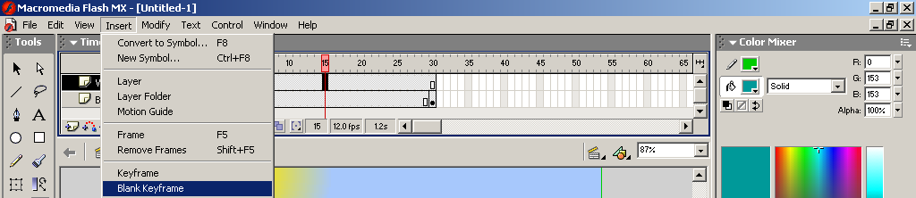

Follow the steps above to create a wave using the pencil tool with smooth mode and the paint bucket to fill it. Your second wave should look different than your first.
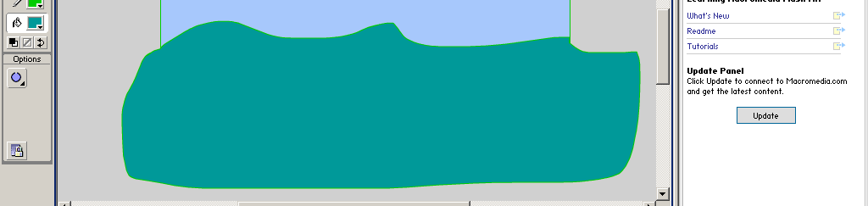

At frame 60 of your Wave 1 layer, choose Insert>Timeline>Blank Keyframe. Follow the steps above to create a third wave using the pencil tool with smooth mode and the paint bucket to fill it. This wave should also look different then the other two.
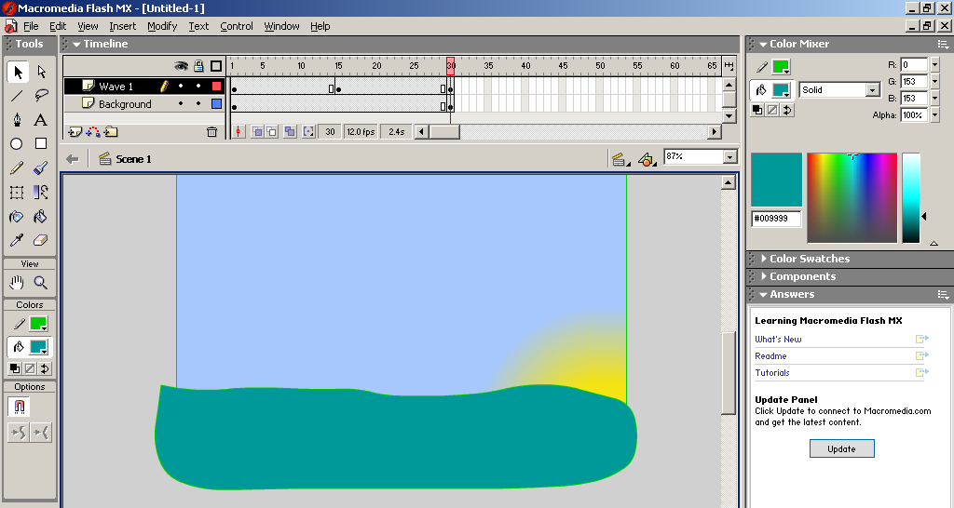

Now click on the Wave 1 layer name and in the Properties inspector choose Shape from the Tween pull-down menu. (Just like we did with the background layer.)

Wave Layer 2
Follow the directions above for Wave 1 and make another wave layer above the one you just created. (Be sure to use a different color for the wave so you can see the contrast.)
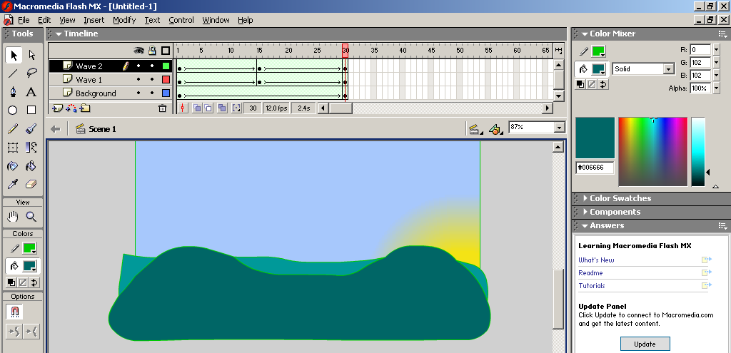

Boat Layer
Add a new layer and name it Boat. Using the Rectangle tool, on the first frame of your Boat layer, draw a rectangle in the middle of your screen with a brown line and brown fill.
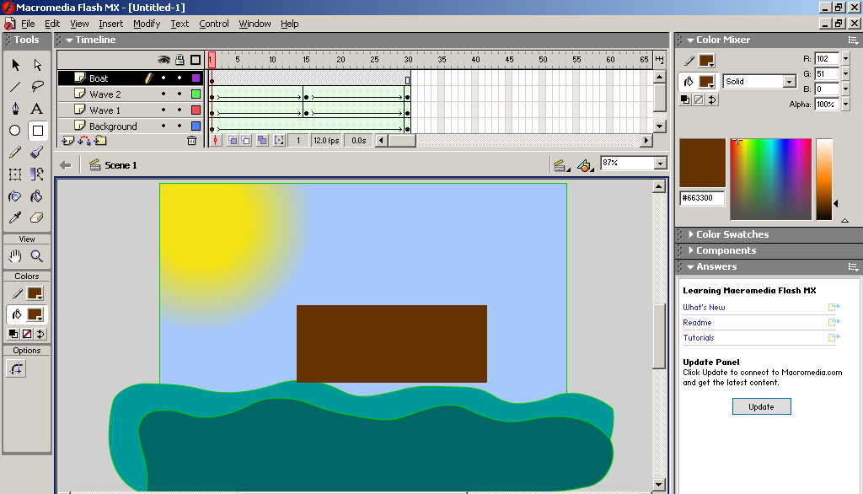

Using the black arrow tool, you can “push” and “pull” the lines of an object. Make sure the object is not selected – or choose Edit>Deselect All – and bring your mouse up to the line. When your mouse is over the line, the arrow changes to include a semi-circle at the bottom right corner. If you are at the corner of an object, the arrow changes to include a 90º angle (backwards L). When the arrow changes you can click and drag to change the shape of the object. For this project, I made changes to the places below that have a white dot on them.

After pushing and pulling the shape, it should look something like this.
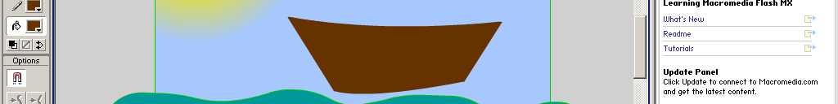
Once you’ve reshaped your boat, using the rectangle tool, draw a mast for your sail.
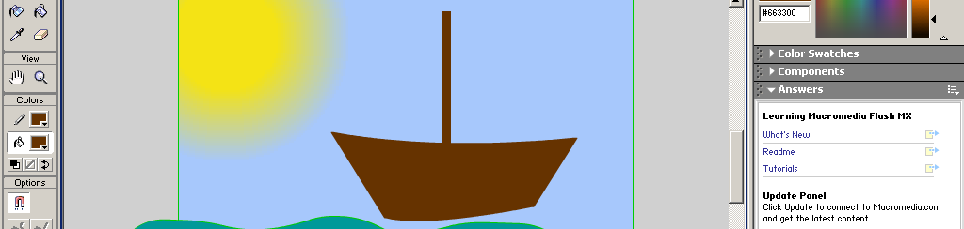

Using the straight line tool, draw a three-sided object (triangle) that can be used and the shape changed for your sail. After you draw the shape with the straight line tool, fill it with the paint bucket.
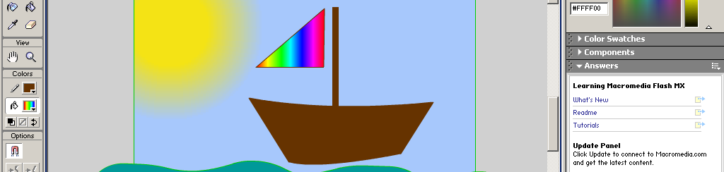

Next, use the black arrow tool to reshape the sail to look like it’s billowing.
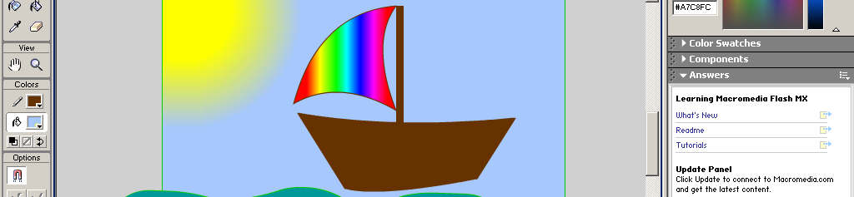

Click on the first frame of the Boat layer so that your entire boat is selected. Choose Insert>Convert to Symbol from the menus.
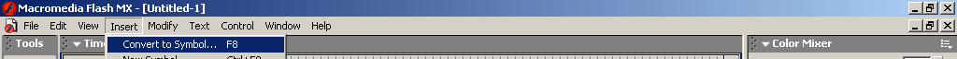

In the pop-up menu, choose the Graphic button, name it Boat and click OK.
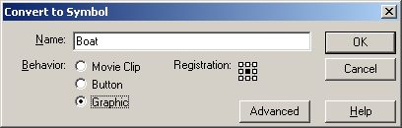

Your boat should now have a blue box around it and a dot in the middle. Click on frame 60 of your Boat layer and Insert>Timelin>Keyframe.
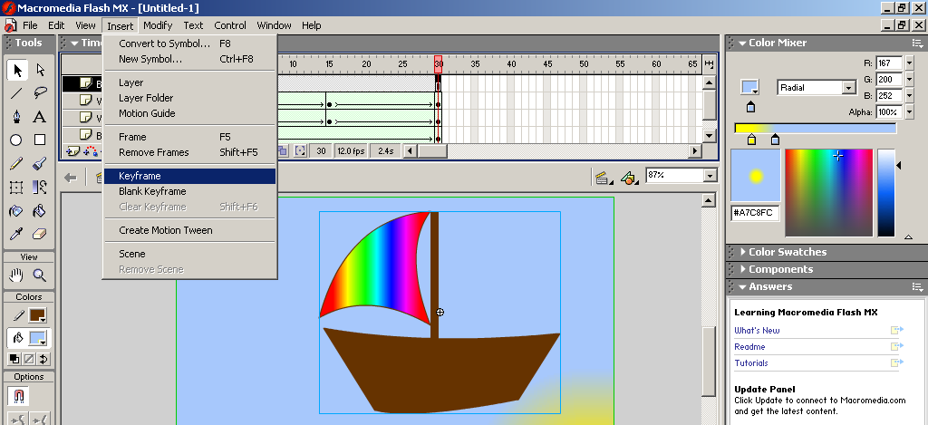

When you convert something to a symbol, to animate it you will need to choose Motion from the Tween menu. Remember to click on the layer name before you choose Shape from the Tween pull-down menu in the Properties inspector.
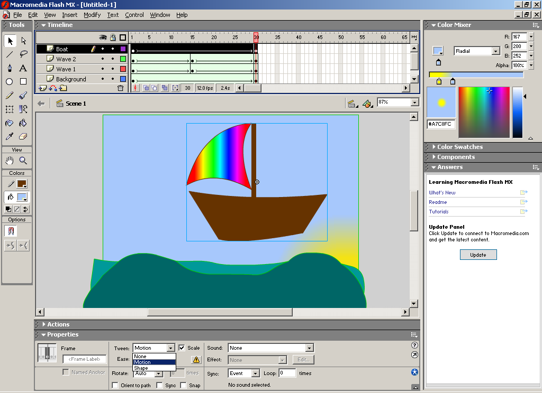

On the first frame of the Boat layer, move the boat where you want it to start.
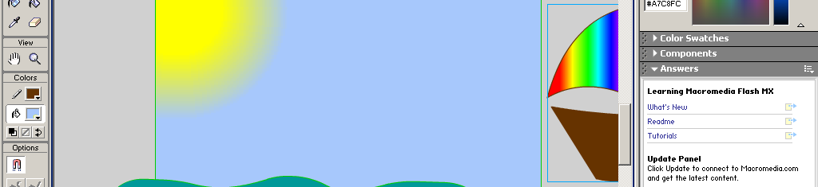

On the last frame of the Boat layer, move the boat where you want it to end.
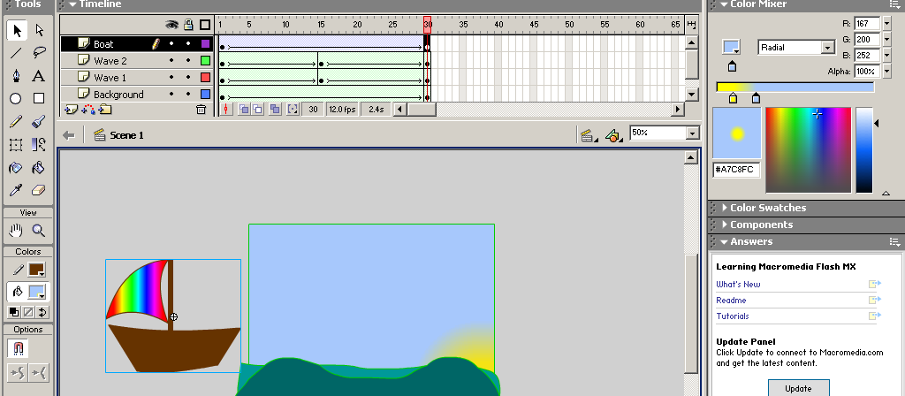

Adding a Motion Guide Layer. Right-click on the Boat layer name and choose Add Motion Guide from the pop-up menu.
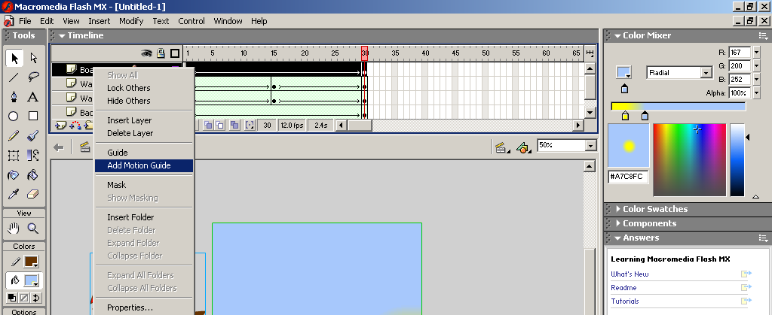

A new layer appears above the Boat layer named Guide:Boat. This layer has a simple job and has ONLY one thing on it. Click on the first frame of the Guide:Boat layer, with the pencil tool and smooth mode option selected, draw a squiggly line from the center point of your boat to about the center where it ends. This line will not show in your movie, but will be visible when you’re working with your movie.
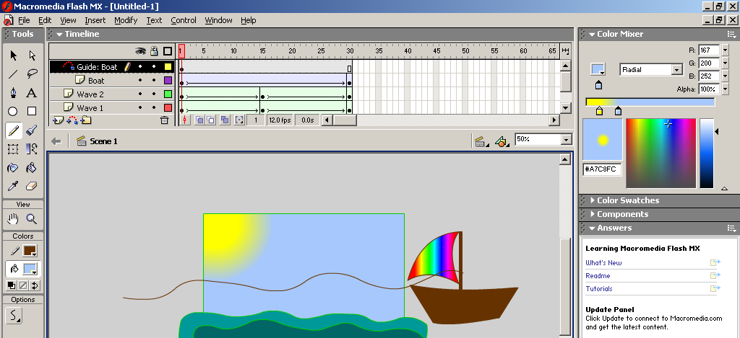

On your Boat layer, click on the first frame and using the black arrow tool line up the dot in the center of the boat with the start of the line.
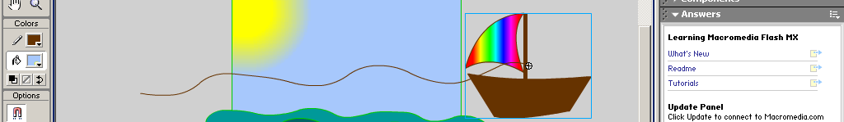

Click on the last frame of your Boat layer and using the black arrow tool line up the dot in the center of the boat with the end of the line.
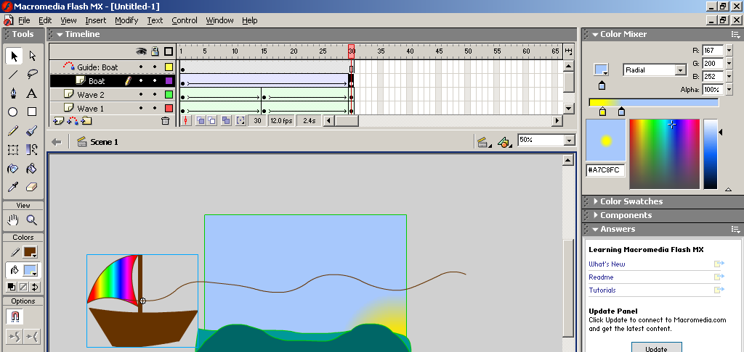

Choose Control>Test Movie. This will export your movie to a .SWF file and allow you to preview it in a player. Your boat should move, you should have a sun that moves from point A to point B, and your waves should be moving too. The guide line will disappear in your test movie window, but your boat should be bobbing up and down with the line.
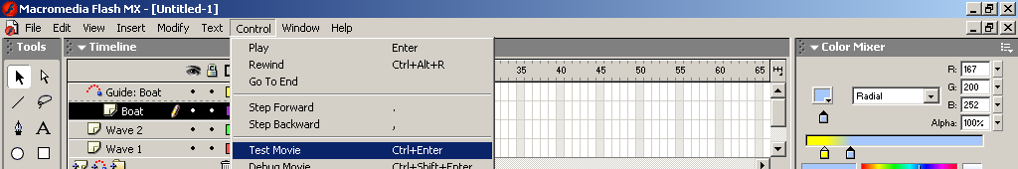
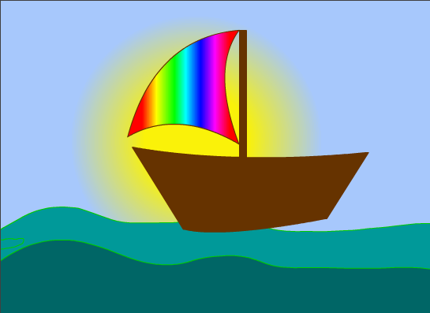

For every layer that is animated (or has a Tween) you will see an arrow. If the arrow is broken in the layer frames then something is wrong. Make sure any item you Shape Tween is not grouped or converted into a symbol. If you want to use Motion Tween, make sure it is grouped or converted to a symbol.

Now add a layer of your own. May I suggest a bird? clouds? fish? You get to choose.

